**Final Report | Capstone Project – The Battle of Neighbourhoods Finding a Better Place**

**in Scarborough, Toronto**

**1. Introduction:**

The purpose of this Project is to help people in exploring better facilities around their neighbourhood. It will help people making smart and efficient decision on selecting.

great neighbourhood out of numbers of other neighbourhoods in Scarborough, Toronto.

Lots of people are migrating to various states of Canada and needed lots of research for good housing prices and reputed schools for their children. This project is for

those people who are looking for better neighbourhoods. For ease of accessing to Cafe, School, Supermarket, medical shops, grocery shops, mall, theatre, hospital, like

minded people, etc.

This Project aim to create an analysis of features for a people migrating to Scarborough to search a best neighbourhood as a comparative analysis between neighbourhoods.

The features include median housing price and better school according to ratings, crime rates of that area, road connectivity, weather conditions, good.

management for emergency, water resources both fresh and wastewater and excrement conveyed in sewers and recreational facilities.

It will help people to get awareness of the area and neighbourhood before moving to a new city, state, country, or place for their work or to start a new fresh life.

**2. Data Section**

Data Link: **https://en.wikipedia.org/wiki/List_of_postal_codes_of_Canada:_M**

Will use Scarborough dataset which we scrapped from Wikipedia on Week 3. Dataset consisting of latitude and longitude, zip codes.

Foursquare API Data:

We will need data about different venues in different neighbourhoods of that specific borough. To gain that information, we will use "Foursquare" locational.

information. Foursquare is a location data provider with information about all manner of venues and events within an area of interest. Such information includes venue.

names, locations, menus and even photos. As such, the foursquare location platform will be used as the sole data source since all the stated required information can be.

obtained through the API.

After finding the list of neighbourhoods, we then connect to the Foursquare API to gather information about venues inside each neighbourhood. For each

neighbourhood, we have chosen the radius to be 100 meters.

The data retrieved from Foursquare contained information of venues within a specified distance of the longitude and latitude of the postcodes. The information obtained.

per venue as follows:

1. Neighbourhood

2. Neighbourhood Latitude

3. Neighbourhood Longitude

4. Venue

5. Name of the venue e.g., the name of a store or restaurant

6. Venue Latitude

7. Venue Longitude

8. Venue Category

Map of Scarborough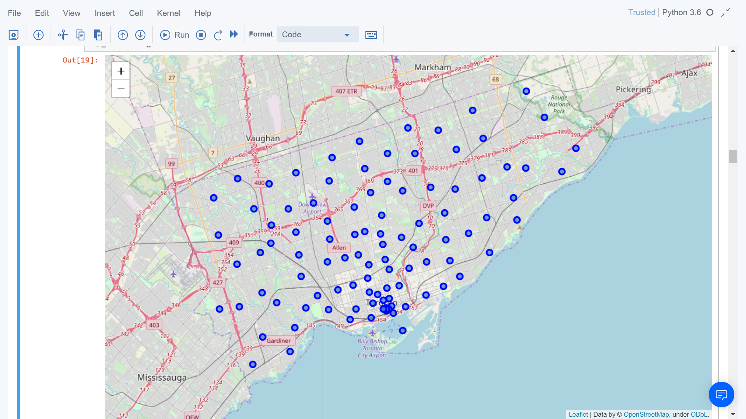

**3. Methodology Section**

**Clustering Approach:**

To compare the similarities of two cities, we decided to explore neighbourhoods, segment them, and group them into clusters to find similar neighbourhoods in a big city like

New York and Toronto. To be able to do that, we need to cluster data which is a form of unsupervised machine learning: k-means clustering algorithm.

Using K-Means Clustering Approach

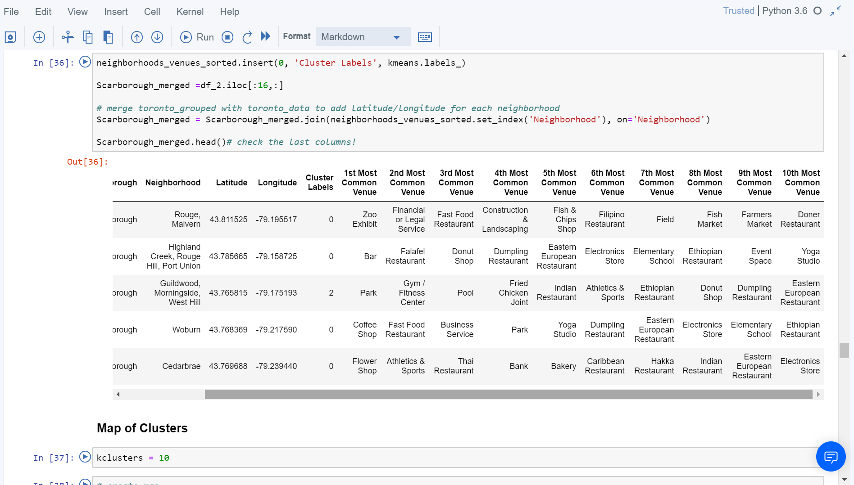

Most Common venues near Neighbourhood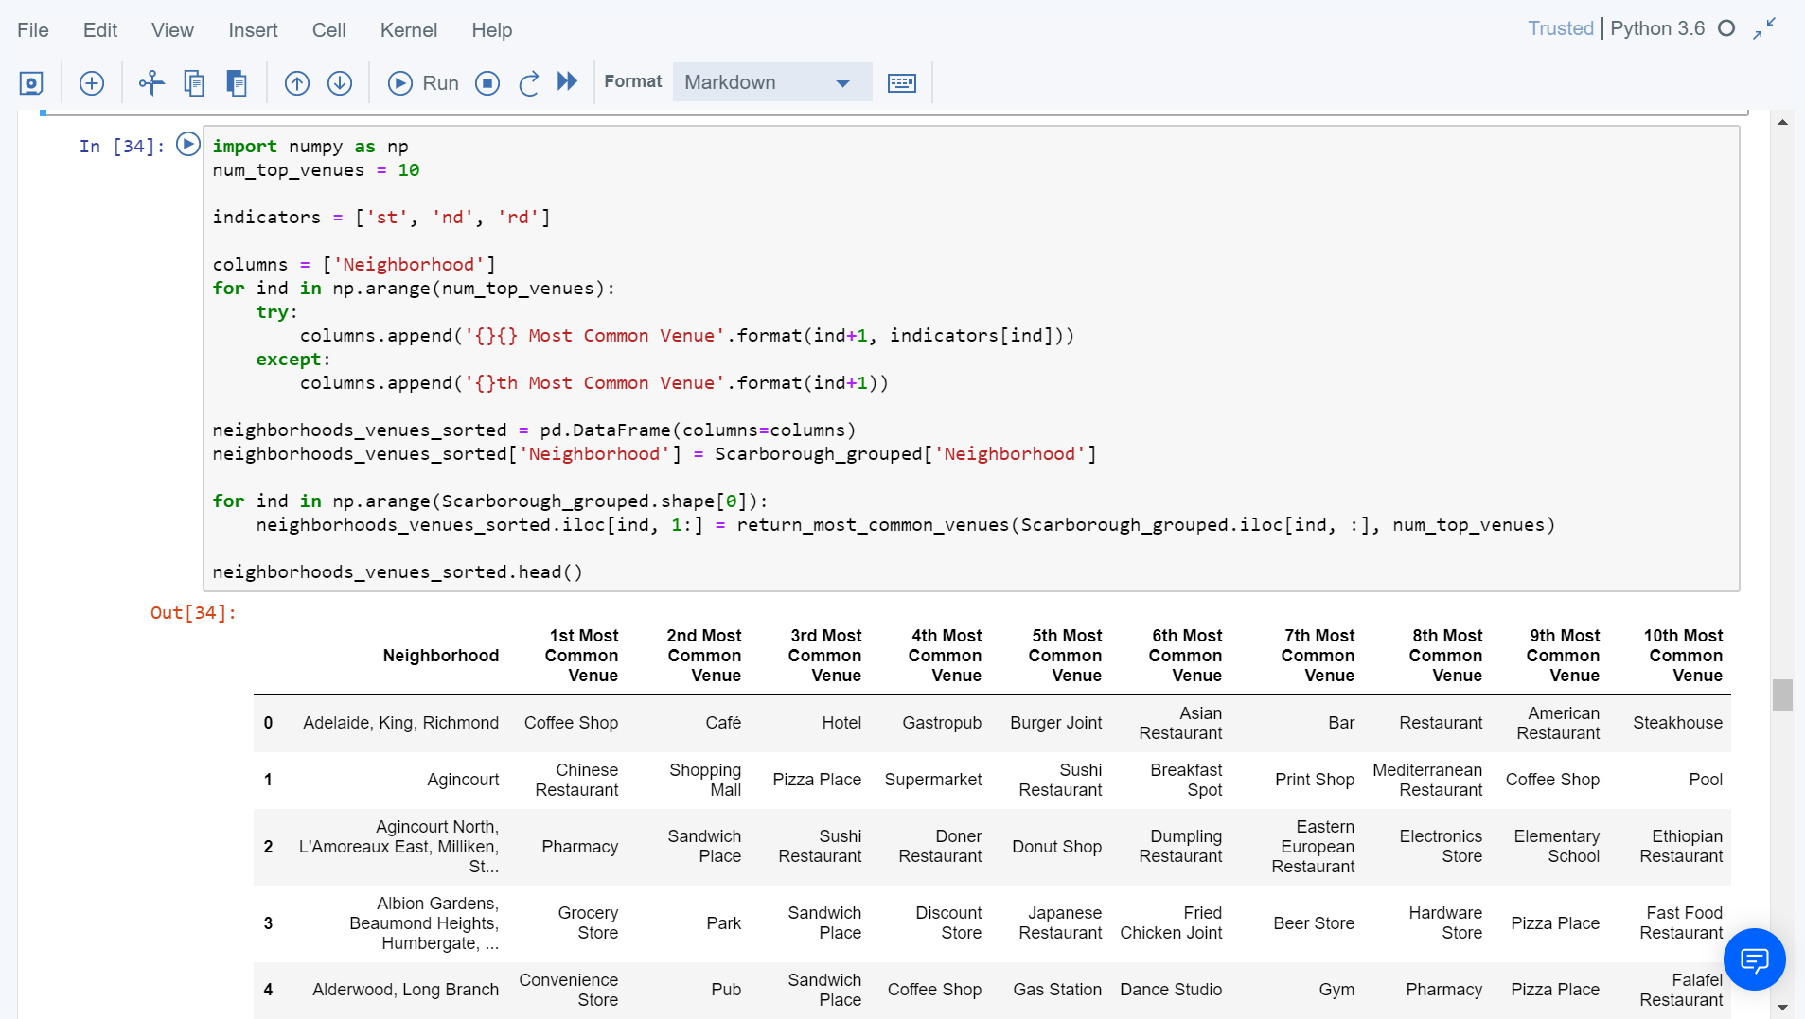

Workflow:

Using credentials of Foursquare API features of near-by places of the neighbourhoods would be mined. Due to http request limitations the number of places per

neighbourhood parameter would reasonably be set to 100 and the radius parameter would be set to 500.

**4. Results Section**

Map of Clusters in Scarborough

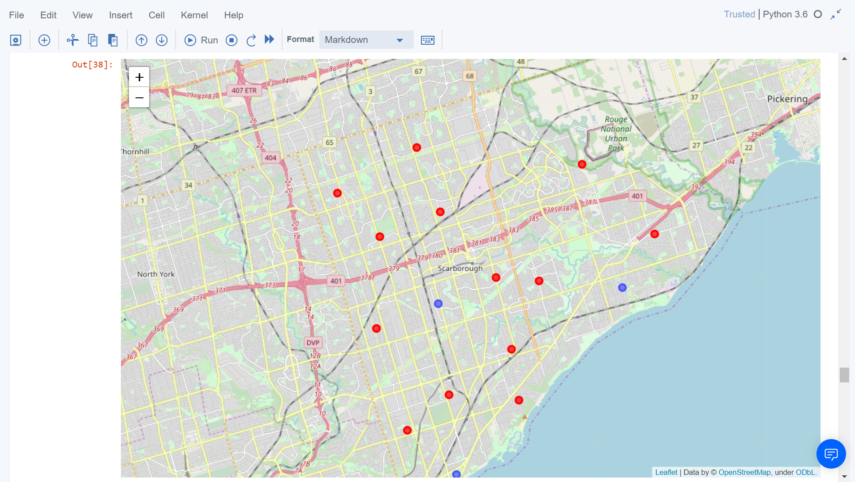

Average Housing Price by Clusters in Scarborough

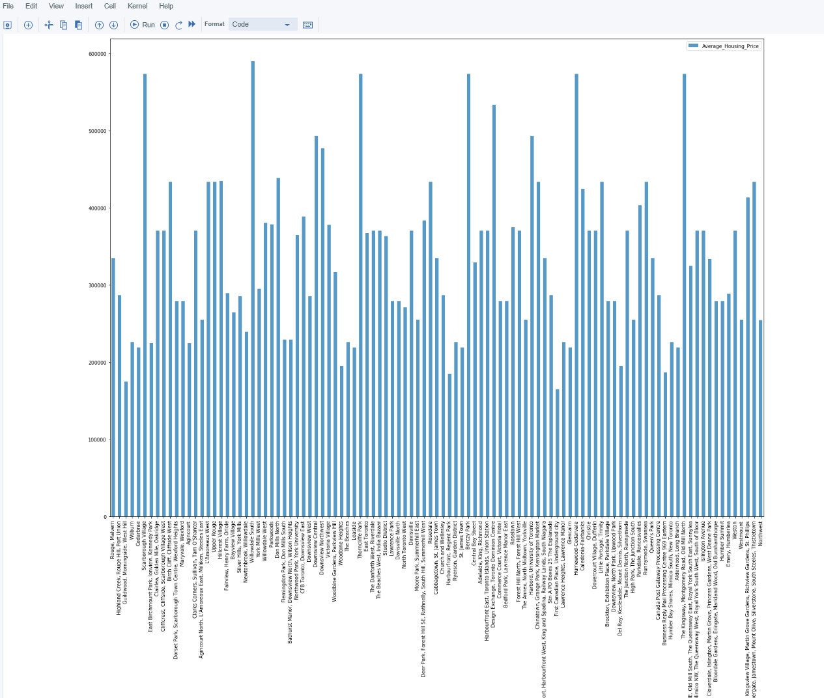

School Ratings by Clusters in Scarborough

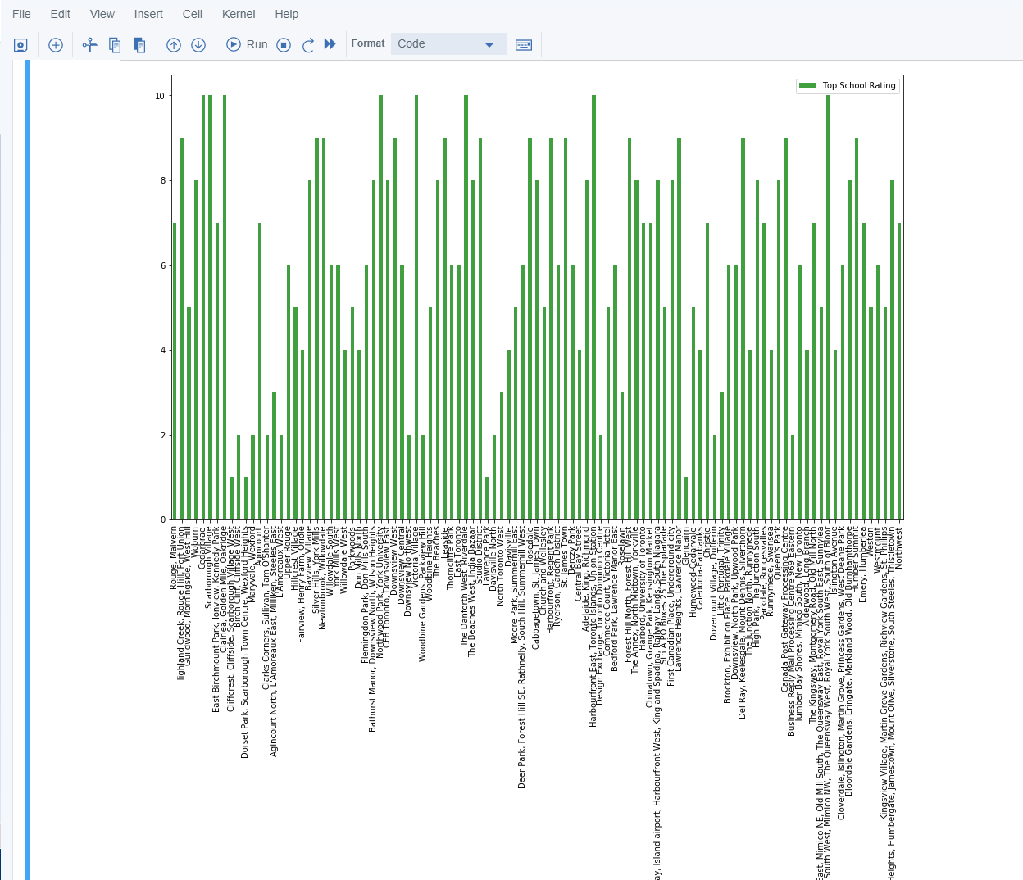

The Location:

Scarborough is a popular destination for new immigrants in Canada to reside. As a result, it is one of the most diverse and multicultural areas in the Greater Toronto Area,

being home to various religious groups and places of worship. Although immigration has become a hot topic over the past few years with more governments seeking more

restrictions on immigrants and refugees, the general trend of immigration into Canada has been one of on the rise.

Foursquare API:

This project has used Four-square API as its prime data gathering source as it has a database of millions of places, especially their places API which provides the ability.

to perform location search, location sharing and details about a business.

**5. Discussion Section**

Problem Which Tried to Solve:

The major purpose of this project is to suggest a better neighbourhood in a new city for the person who are shifting there. Social presence in society in terms of like

minded people. Connectivity to the airport, bus stand, city centre, markets, and other daily needs things nearby.

1. Sorted list of houses in terms of housing prices in an ascending or descending order

2. Sorted list of schools in terms of location, fees, rating, and reviews

6. Conclusion Section

In this project, using k-means cluster algorithm I separated the neighbourhood into 10(Ten) different clusters and for 103 different latitude and longitude from dataset, which.

have very-similar neighbourhoods around them. Using the charts above results presented to a particular neighbourhood based on average house prices and school rating.

have been made.

I feel rewarded with the efforts and believe this course with all the topics covered is well worthy of appreciation. This project has shown me a practical application to

resolve a real situation that has impacting personal and financial impact using Data Science tools. The mapping with Folium is a very powerful technique to consolidate.

information and make the analysis and decision better with confidence.

**Future Works:**

This project can be continued for making it more precise in terms to find best house in Scarborough. Best means based on all required things (daily needs or things

we need to live a better life) around and in terms of cost effective.